Dungeon Climber

(Working Title)

## Overview

Dungeon Climber is a multiplayer virtual reality game built for the HTC Vive. The game focuses on immersive interaction with the environment and cooperation with other players, enabling players to work together to solve challenges and progress through levels in virtual reality.

## Controls

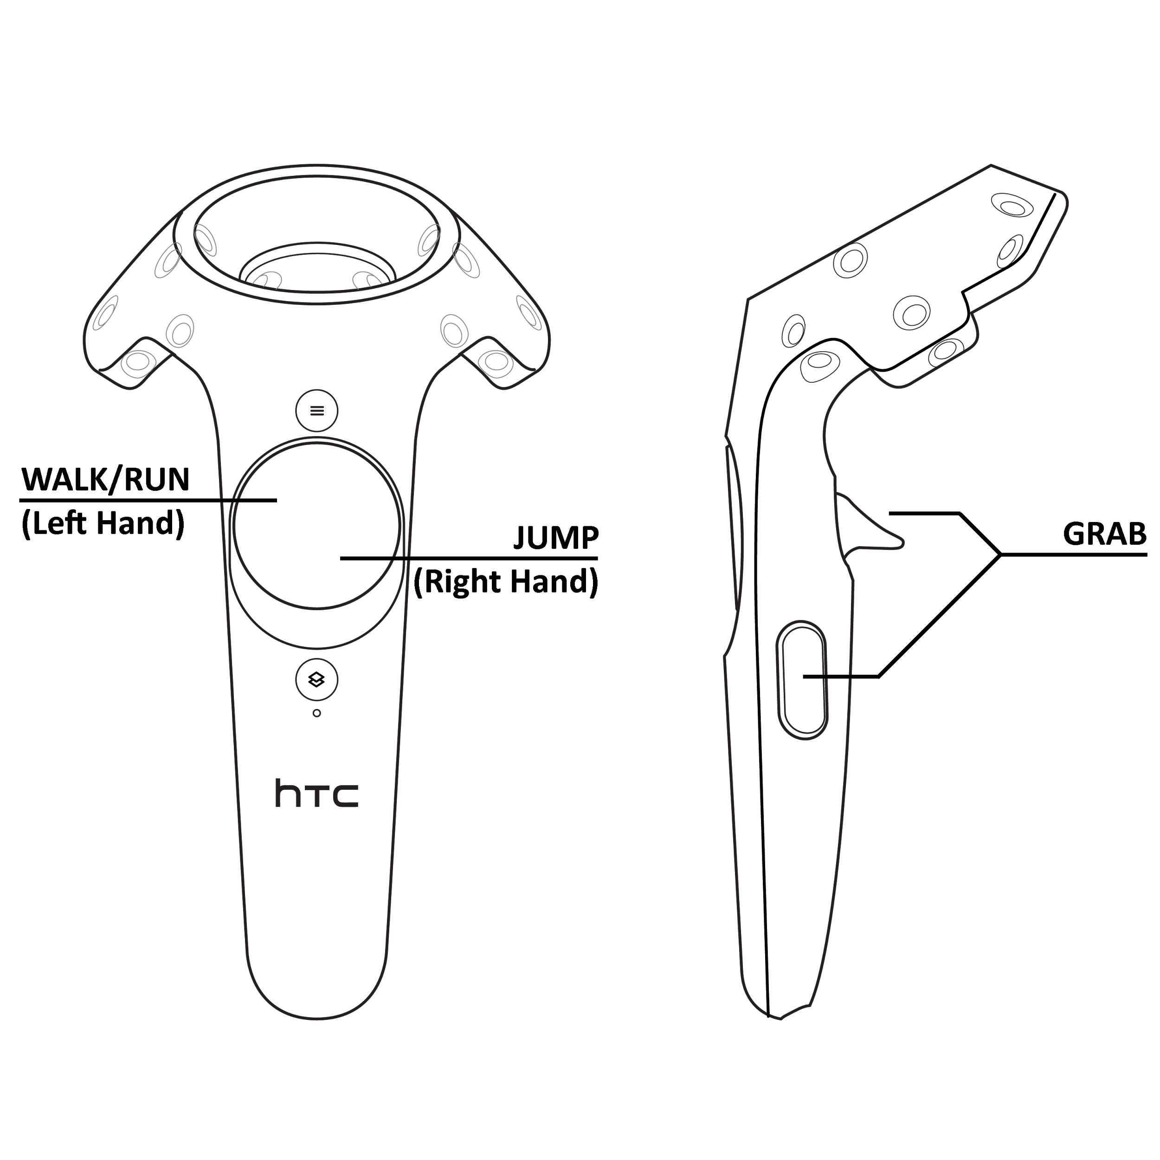

Dungeon Climber uses the HTC Vive and SteamVR’s standing play space, allowing the player to move around in real space while interacting with the game’s environment. While the player can walk in real space to move in the game, they can also press down on the left trackpad, with the direction pressed on the trackpad relative to the facing direction on the headset. The player will also move at different speeds based on the distance to the center that the left trackpad is pressed at, moving faster at the trackpad is pressed closer to the edge. The player can jump by pressing anywhere on the right hand’s trackpad, allowing them to cross gaps and navigate levels. Using the trigger or grip buttons, located on the back and sides of each controller, the player can grab objects in the game. Some objects, while being grabbed, can be carried by the player and will follow the player’s hand movements in real space, while heavier objects will remain stationary but allow the player to move themselves relative to the object, allowing the player to climb. To make climbing and grabbing easier, a player can hold a grip button before moving their hand to the object they want to grab, with the object becoming locked to the hand only when the two make contact. This is so that the player does not have to coordinate pressing a grip button exactly when their hand may be close enough.

## Player Mechanics

Climbing and grabbing objects is the primary mechanic that the game uses for challenges and puzzles. Since it is physics based, it has many potential gameplay uses, requiring minimal additional development. For example, the existing mechanic that allows a player to grab lightweight objects and move them around also allows the player to throw a rock at an enemy, physically pull a lever or open a door, push a key into a lock and turn it, or use two swords as stilts. Maintained motion after releasing a grab button lets the player throw objects, but also allows the player to push themselves away from a surface they are climbing, launching through the air based on the direction and force that the player used. Other mechanics that a player uses are the player’s health, and equipped items. In the current game, each player has three health points, viewable as three hearts on the back of their left hand, that may lower if the player is hit by an enemy or a hazard in a level. When the player’s health reaches zero, they are taken back to the level’s starting point with full health. Players will be able to equip various items in the game, though only a sword is available in the current version. The player can draw a sword by reaching for their left hip, using the grab button to draw their weapon, and will be able to re-draw the sword even if it is lost somewhere in a level. Planned items could include other weapon types with increased damage or longer reach, as well as other useful items like lanterns and potions.

## Combat and Enemies

Levels and challenges in Dungeon Climber can include various enemies that will harm or attack the player. The game’s only enemy in the current version, the kobold, looks like a slightly smaller version of the player that wanders in small groups. Enemies become aggressive if the player gets too close, and will chase the player while swinging their fists. An enemy can lower the player’s health if their fists make contact, but the player can quickly kill the enemy by punching or swinging the sword item. Since physical contact must be made to inflict damage, combat requires the player to move their arms in real space, trying to harm an enemy without getting hit themselves. The location that an enemy is hit matters as well, as kobolds will take more damage and be stunned a bit longer if hit in the head. There is currently no way to harm other players, but this may change in a later version of the game.

## Level Mechanics and Collectibles

## Aside from grabbing and climbing mechanics, the current gameplay takes inspiration from games like Super Mario 64, where players travel through levels while overcoming platforming challenges, defeating monsters, and solving puzzles. Players start in a hub level that also functions as a tutorial, and can proceed to a number of different levels with varying challenges and themes, as well as a range of difficulty. Each level has a large amount of coins scattered throughout it, which players can pick up with the grab button, and can later be used to buy new weapons or other items. Players can also find keys and key pieces, allowing new levels to be opened after a certain number has been collected. The amount of keys and coins that a player has collected can be viewed on the back of their left hand, under the player’s remaining health. Future level design will likely focus on more linear levels that can be enjoyed and completed quickly, with less focus on long-term progression.

## Multiplayer

Dungeon Climber’s mechanics are complemented by additional players, with future levels either requiring more than one person or having unique solutions that more than one player can take advantage of. Using the grab button, a player can hold onto another player and lift them up like an object. This allows for platforming challenges such as requiring a person to help another onto a ledge, followed by the second player taking the first’s hand and helping them up. For higher ledges, or large gaps, a player can also be tossed into the air, though a player who does not want to be thrown can prevent this by grabbing the player who is about to throw them, holding the two together.

## Art and Sound

All art and sound in the current version of the game is stand-in, and is meant as a placeholder for higher quality assets. Current sound effects like coin collecting and enemy mumbles are free-to-use sounds from the Unity asset store, and have a chiptune 8-bit theme similar to old arcade games. The game’s 3D models are made with a free-to-use voxel editor, and do not follow any art style that the game may have. Models in the game may still be low-poly, with low model detail so that models match their physical collisions with minimal performance issues, which is important for a VR game. Current levels are only blocked out, meaning that instead of detail and sculpted terrain, each level is mady almost entirely of large blocks. Levels in future versions will also likely have a low-poly design, which is easy to make and good for climbing in VR.